**Multidimensional OLAP – Exercise for Class 4**

Multidimensional OLAP (MOLAP)

Based on our database model, define a MOLAP model with at least one fact and 4 dimensions

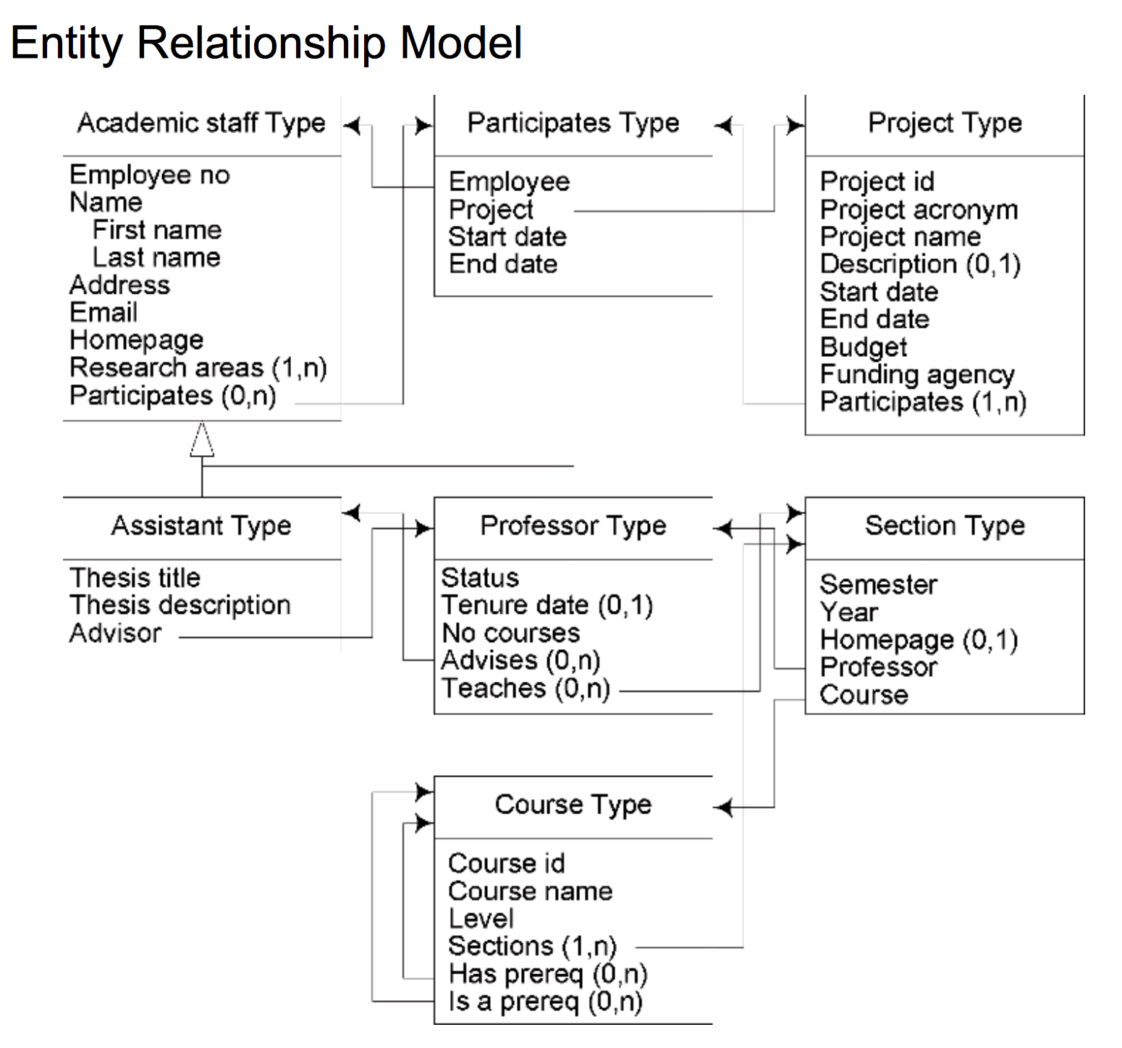

Define the 4 dimensions and 1 fact

Dimensions –

1. Project ID
2. Project Acronym
3. Project Name
4. Description

Fact –

1. Start Date
2. End Date
3. Budget